Title of Abstract (Bold 14pt, TimesNewRoman)

Author1ª, Author2ª, Author3^{b} (size12pt, Underline Presenting author)
ª Affiliation of Author1+2, Address (size 11pt below)
^{b} Affiliation of Author3, Address
Email Address@ContactAuthor (All lines above should be centered)

In the main text, please use the Times New Roman of 11pt size. The abstract should be maximally one page long and one or two figures can be inserted in the text, the total file size of which should be less than 500kB. Page margins of all sides should be 24~30mm.
The word file should be named as your family name plus some short information for identification (like TanabeS-Kyoto-2.doc) and submit by e-mail to "submit@pre12.org".
The sample text. The sample text. The sample text. The sample text. The sample text. The sample text. The sample text. The sample text. The sample text. The sample text. The sample text. The sample text. The sample text. The sample text. The sample text. The sample text. The sample text. The sample text. The sample text. The sample text. The sample text. The sample text. The sample text. The sample text. The sample text. The sample text.
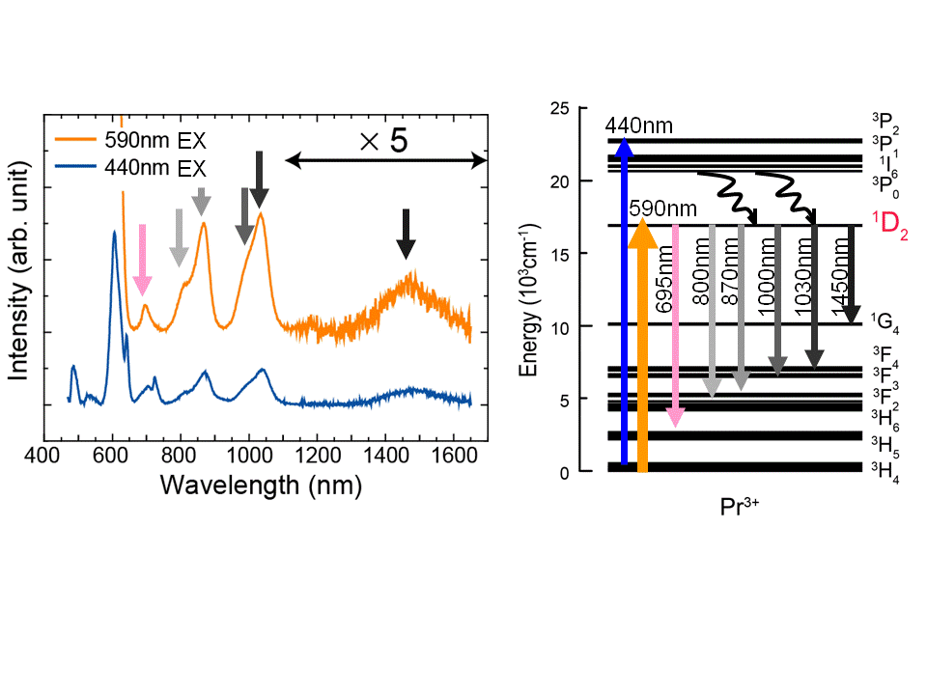
The sample text. The sample text. The sample text. The sample text. The sample text. The sample text. The sample text. The sample text. The sample text. The sample text. The sample text. The sample text. The sample text. The sample text. The sample text. The sample text. The sample text. The sample text. The sample text. The sample text. The sample text. The sample text. The sample text. The sample text. The sample text.
Fig.1: Photoluminescence spectra of Pr³⁺ ion Fig.2: Energy level of Pr³⁺ ion and
in the glass by 440nm and 590nm excitation. related optical transitions.

