4th International Workshop on
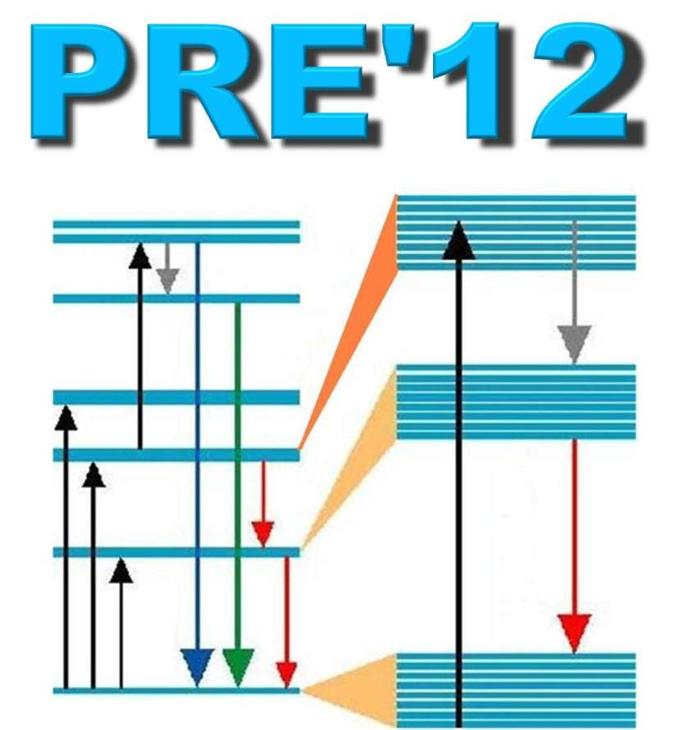
PHOTOLUMINESCENCE IN RARE EARTHS:
PHOTONIC MATERIALS AND DEVICES

PRE’12
Registration Form
Date( / / )
First name | （＋Middle initial, if any)
Last name
Affiliation
Address
Postal code/ Country | /
Phone
FAX
Email
Payment | □Bank Transfer □Credit card □Onsite* (JPY cash only)
*Discount price not applied .
↓ .
Registration payment | - On and Before Jan. 20, 2012 | - Paid after Jan. 20, 2012
Regular | □ JPY 25,000 | □ JPY 30,000
Invited Speaker or Student | □ JPY 16,000 | □ JPY 20,000
Accompanying Person | □ JPY 10,000
Banquet | □ JPY 8,000
Total

Payment by Credit card :
Type of Card | □VISA □Master (no other else)
Holder's name
Card No.
Expiry Data | (Month) / (Year)
Signature

